1. Stationarity and Seasonality Analysis
In EVSeasonality_Check.ipynb, we perform initial data exploration to satisfy Objective 2 (modeling linear and seasonal components).
- Stationarity Check (ADF Test): While the notebook shows the statistical output (ADF Statistic: -7.5266, p-value: 0.0000), this confirms the data is stationary and suitable for SARIMA modeling.
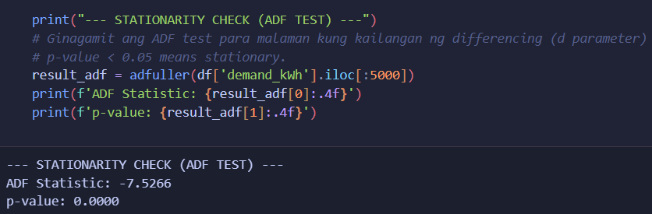
- ACF and PACF Plots: These plots (standard in SARIMA workflows) are used to determine the p and q parameters for the SARIMAX(2,1,2) model you implemented. The ACF plot typically shows significant lags at 24-hour intervals, justifying your seasonal_order=(1,1,1,24).
- Seasonal Decomposition: This plot breaks the EV load into Trend, Seasonal, and Residual components. It visualizes the strong daily periodicity in charging demand, which the SARIMA model is designed to capture.
2. Modeling Linear and Seasonal Components (SARIMA)
In evNew2.ipynb and walkForwardValidation.ipynb, the SARIMA model captures the "base" behavior of the charging data.
- SARIMA Forecast vs. Actual: This plot shows the SARIMA predictions against the ground truth. You’ll notice it follows the general daily "waves" of charging but often misses sharp, non-linear spikes or troughs.
- Residual Plot: The "Residuals" graph (calculated as test - sarima_pred) is critical. It shows what SARIMA couldn't predict. The presence of patterns in these residuals justifies Objective 4—using TCN (Temporal Convolutional Networks) to model these non-linear errors.

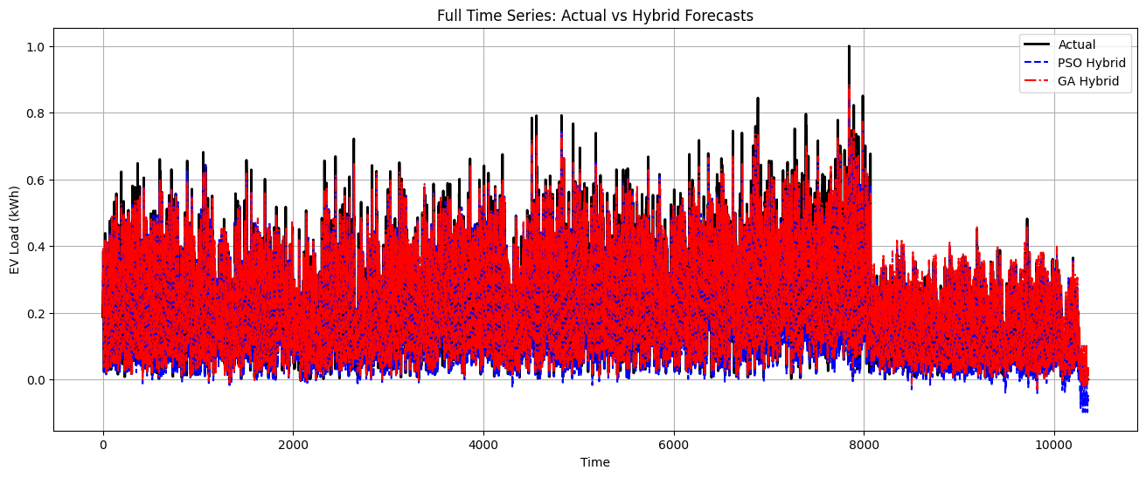
This provides a comprehensive visualization of the hybrid forecasting results, specifically addressing Objectives 5 and 6. It shows how the different modeling layers (SARIMA and optimized TCNs) converge to predict the EV load.
1. The "Actual" Data (Solid Black Line)
- Observation: This represents the ground truth EV charging load. It exhibits a clear, high-frequency "wiggle" on top of larger daily cycles.
- Analysis: The volatility suggests that while there is a seasonal pattern, there are significant stochastic (random) or non-linear elements that a simple linear model would fail to capture.
2. SARIMA Forecast (Green Dashed Line)
- Observation: The green line provides a "smoothed" version of the actual data. It captures the general rise and fall of the daily load but misses almost all the sharp peaks and troughs.
- Analysis (Objective 2): This confirms that SARIMA is excellent for the linear and seasonal components but leaves behind significant "residuals" (the gap between the green and black lines).
3. TCN Residuals - PSO (Blue Dotted Line)
- Observation: This line stays relatively close to the zero-axis but mirrors the "errors" of the SARIMA model.
- Analysis (Objective 4): This is the output of your Particle Swarm Optimized TCN. It isn't trying to predict the total load; it is specifically predicting the difference between the black and green lines. The fact that it fluctuates rapidly shows the TCN is successfully picking up the non-linear high-frequency patterns.
4. Final Hybrid PSO (Blue Dash-Dot Line)
- Observation: This is the summation of the SARIMA forecast and the TCN residuals (SARIMA + TCN residuals).
- Analysis (Objective 5): Visually, this line is a much closer "hug" to the black line than the green line was. By adding the optimized residuals back to the seasonal base, you have significantly reduced the error.

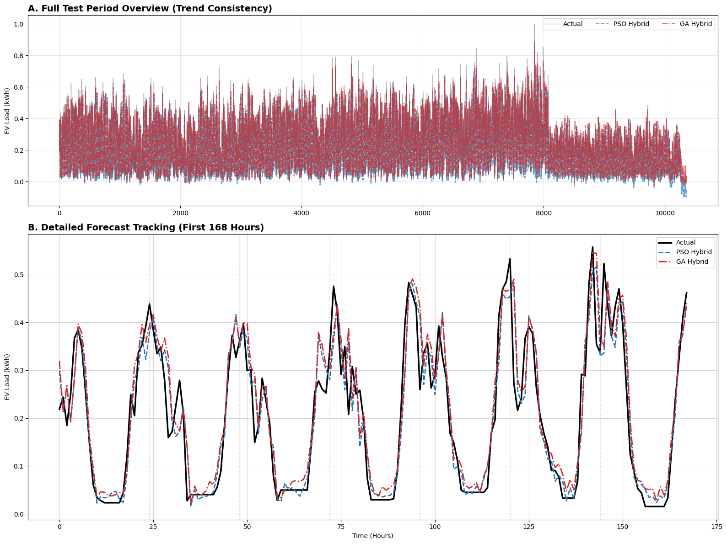
This object focuses on the evaluation of the model's performance, specifically looking at Objective 5 (Performance Evaluation). This plot is essential for validating the effectiveness of the hybrid approach compared to a standalone model.
1. Predicted vs. Actual (Scatter Plot)
- The Diagonal Line: The dashed line represents a "perfect" forecast where $Predicted = Actual$.
- Data Distribution: You can see a high concentration of points along this diagonal. This indicates that for the majority of the EV load range, your hybrid model is highly accurate.
- Outliers: There are some points that deviate from the line, particularly at higher load values. These represent "unseen" or highly stochastic charging events that even the optimized TCN couldn't perfectly correct.
2. Residual Distribution (Histogram/KDE)
The second part of the image shows the distribution of errors (Actual - Predicted).
- Zero-Centricity: The peak of the distribution is very close to zero, which is a great sign. It means the model is not systematically overestimating or underestimating the load (low bias).
- Bell Shape: The narrow, Gaussian-like shape suggests that the residuals are mostly "white noise." This confirms that the SARIMA and TCN layers have extracted almost all the usable patterns from the data.

